STUDENTS MANAGEMENT SYSTEM USING QR CODE

INTRODUCTION
SMS Text Messaging Alert Systems, the new generation Business Messaging System, is the ultimate in SMS revolution that sends out individualized, Bulk text/Flash messages directly from your PC to the recipient without internet Connectivity.
SMS Text Messaging Alert Systems is an application that can be installed in a laptop, desk top or a server with a GSM device connected to it to act as a SMS server linked to the service provider. For sending messages in bulk, with specified task and with numerous features. Else in mobile phone this won’t be possible to send it fast.
The proposed solution offers a QR code for the students to scan it via a specific Smartphone application. The code along with the student identity taken by the application will confirm the student’s attendance.This way, the system will save not only time but also efforts that were supposed to be put by instructors during each lecture. It will speed up the process of taking attendance and leave much time for the lecture to be given properly.
The proposed system also takes care of preventing unauthorized attendance registration using multi-factor authentication. That is, it considers “Something you know”, “Something you have”, and “Something you are” to confirm the student identity.

OBJECTIVES
The main objective of the QR code attendance system is to develop a comprehensive software system for the educational institutions which facilitates a simple and non-verbose approach to manage the administration of the organisation.
We intend to create a system the provides the following features :
- To maintain a database of the students which aids student academic performance monitoring by the Parents.
- To maintain a database of the faculty which maintains Teacher performance based on the pass percentage(%) of students of their respective classes.
- To send SMS alerts to the parent/guardian of a particular student in the scenario of the student failing in a particular subject.
- Allow access of student/teacher details via mobile/PDA devices.
- Providing freedom to the students and teachers to upload notes, slides , previous years question papers, etc to aid fellow students.

EXISTING SYSTEM AND ITS DISADVANTAGE
- A separate person for intimating students and staff’s regarding notice has to be kept.
- Event and Placement notifications and timings may not be received by students and staff if they are absent.
- The purpose of developing attendance management system is to computerized the tradition way of taking attendance.
- In the college community, every year, thousands of students miss examination due to sudden change of examination time table. Most of the time, the information is placed on the notice board and not all students can access it.
- Another purpose for developing this software is to generate the report automatically at the end of the session or in the between of the session.
DISADVANTAGES
- Only the performance with respect to the academic curriculum is maintained, extra curricular activities’ details are not adequately explained.
- The SMS alert service cannot be assured delivery of the messages in case of a network jam.
- This is not device independent.

PROPOSED SYSTEM AND ITS ADVANTAGES
- Colleges and universities can utilize the information power of our alert system to improve their communication with students and the staff.
- The manual process like making phone call, sending post’s which more costly compare to SMS system are can be avoided.
- Now days everyone has cell phones, it’s easy to notify regarding events and other activities using SMS system.
- Marks and attendance can be sent using SMS system provided in GSM SIM using QR code, Client to Server communication for students reference of notes.
- Since SMS rate is very low compared to other means, it can be easily used for advertising product.
- Time Table Generator, Notification to Parents for their consoled students.
- Lecture details & subject Details.

ADVANTAGES:
- Individual profile for each student and teacher in the institution which can be accessed using the USN (student) or the employee number (teacher) to check performances, attendance, status of pending requests and to upload documents.
- SMS alerts which are to be sent to parents of pupils which contain the their child’s performance details and also institution faculty contact numbers which are to be used in case the parent wants any further clarifications.
- Students and Parents can login anytime for various queries regarding the institution round the clock, 24 hours a day and 365 days a year.
- Parents are sent regular SMS alerts about their child’s progress, thus making monitoring their performance a much easier task.
- It has a user friendly user interface for the convenience of parents and also students and teachers, both of whom who can upload articles or notes using the QR code system.
- The faculty in charge can monitor the teachers and their performances during the curriculum through performance charts or graphs.

TOOLS USED
Hardware:
- A Processor having a clock speed of at least 1 GHz .
- A minimum of 256MB RAM of primary memory.
- A secondary memory of a minimum of 100GB is required.
- A GSM modem/server to send SMS alerts is required.
- A mobile phone or a GSM modem is required to receive SMS alerts.

Software:
- Operating System : Windows xp, 7
- Languages : Java, JavaScript, XML, CSS
- Compilers : Java C compiler, J2EE
- Software :Eclipse
- Database :SQLITE
- Tools used :Text editors

Functional Requirements
- The user must enter a valid log in ID, i.e USN if the user is a student and/or student’s parent /guardian and teacher’s employee number if user is a teacher. After this the user must enter a valid password.
- If the user has entered a wrong ID/password prompt him/her to enter the correct id/password upto three times, after which start a password recovery procedure.
- Else if the user has entered the correct ID- password combination then opens the respective user page providing the various browsing options i.e student/teacher performance graph, address, etc.
- If the user chooses to see his academic details then retrieve the details from the database and display the results.
- After the necessary details are got then the user logs out of his/her window after which the changes are saved and the user page is exited.
- The administrator regularly updates the details of the students/teachers , and each month if the respective student has failed to clear any subject then it sends a SMS alert to the respective parents, thus intimating them.

Non Functional Requirements
- Secure access of confidential data.
- 4x7 availability
- Better component design to get a better peak time performance.

Software Requirement Specification
GSM
GSM (Global System for Mobile Communications: originally from Group Spécial Mobile) is the most popular standard for mobile telephony systems in the world. The GSM Association, its promoting industry trade organization of mobile phone carriers and manufacturers, estimates that 80% of the global mobile market uses the standard. GSM is used by over 1.5 billion people across more than 212 countries and territories. Its ubiquity enables international roaming arrangements between mobile network operators, providing subscribers the use of their phones in many parts of the world. GSM differs from its predecessor technologies in that both signaling and speech channels are digital, and thus GSM is considered a second generation (2G) mobile phone system. This also facilitates the wide-spread implementation of data communication applications into the system.
The ubiquity of implementation of the GSM (Global System Market) standard has been an advantage to both consumers, who may benefit from the ability to roam and switch carriers without replacing phones, and also to network operators, who can choose equipment from many GSM equipment vendors. GSM also pioneered low-cost implementation of the short message service (SMS), also called text messaging, which has since been supported on other mobile phone standards as well.
- GSM is a cellular network, which means that mobile phones connect to it by searching for cells in the immediate vicinity. There are five different cell sizes in a GSM network—macro, micro, pico, femto and umbrella cells. The coverage area of each cell varies according to the implementation environment. Macro cells can be regarded as cells where the base station antenna is installed on a mast or a building above average roof top level. Micro cells are cells whose antenna height is under average roof top level; Picocells are small cells whose coverage diameter is a few dozen metres; they are mainly used indoors. Femtocells are cells designed for use in residential or small business environments and connect to the service provider’s network via a broadband internet connection. Umbrella cells are used to cover shadowed regions of smaller cells and fill in gaps in coverage between those cells.
- Cell horizontal radius varies depending on antenna height, antenna gain and propagation conditions from a couple of hundred meters to several tens of kilometres. The longest distance the GSM specification supports in practical use is 35 kilometres (22 mi).

JAVA Introduction
Java is a high-level, third generation programming language, like C, FORTRAN, Smalltalk, Perl, and many others. You can use Java to write computer applications, process words, play games, store data or do any of the thousands of other things computer software can do.
Key Differences between C++ and Java:
No pointers Just references
Java has references but there are no pointers. This basically means there is no way for you to directly access the memory that has been reserved for an object except through the use of the object or primitive itself. It is possible to have multiple objects of the same type referencing the same memory. In C++ it is possible to have multiple object and primitive pointers pointing at the same block of memory and for each to operate on it in a different way.
Java is Object-Oriented
In C++ you can have functions that are not attached to classes. The main function in C++ is explicitly not attached to a class. In Java, all function, including the main function, are attached to classes that means within class. Everything is an object here.
Java is a Platform-Independent
When Java program is compiled; it produces a special format called byte code and not executable code. Java bytecode is executed by Java run-time system, which is called Java Virtual Machine. In its standard form, JVM is an interpreter for bytecode. Java bytecode is exactly the same on every platform. Only JVM needs to be implemented on every machine. Thus details of JVM differ from platform to platform. The interpreter reads the byte code and translates it into the native language of the host machine on the fly. Since the byte code is completely platform independent, only the interpreter and a few native libraries need to be ported to get Java to run on a new computer or operating system. Thus due to JVM, Java becomes architecture neutral.
Java is safe and simple
Java was designed from the ground up to allow for secure execution of code across a network, even when the source of that code was not trusted and possibly malicious. Furthermore Java has strong typing. Variables must be declared, and variables do not change types when you aren't looking.. Thus you can cast an int to a long but not an int to a String. Java implements a robust exception handling mechanism to deal with both expected and unexpected errors.

Java is Multithreaded
Java is inherently multi-threaded. A single Java program can have many different threads executing independently and continuously. Three Java applets on the same page can run together with each getting equal time from the CPU with very little extra effort on the part of the programmer.
Java has Garbage Collector
One of the most difficult tasks in C++ is keeping track of objects and then deleting those to free up memory and prevent data leaks. In Java there is no delete command because Java does memory garbage collection for free when objects are no longer referenced. There is a slight performance decrease associated with this service, but it greatly aides in providing reliable crash free programs. There are constructors and these do allocate memory on the heap, but this is transparent to the programmer.
Use of try and catch mandatory
For the most severe and common errors in Java the use of catch and try is mandatory. It is built into Java’s grammar that these error checking precautions must be present or else your program will not compile. In C++, catch and try are also available, but are not mandatory.

Messages
Messages are central to any electronic mail system. This section discusses how to implement them for your provider.
The Structure of a Message
The Message class models an electronic mail message. It is an abstract class that implements the Part interface. The Message class defines a set of attributes and content for an electronic mail message. The attributes, which are name-value pairs, specify addressing information and define the structure of the message’s content (its content type). Messages can contain a single content object or, indirectly, multiple content objects. In either case, the content is held by a Data Handler object.
Simple Messages
A simple message has a single content object, which is wrapped by a Data Handler object. FIGURE 2-1 shows the structure of a Message object:

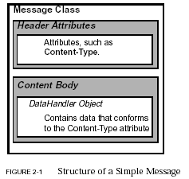
Multipart Messages
In addition to the simple structure shown in FIGURE 2-1, messages can also contain multiple content objects. In this case the Data Handler object contains a Multipart object, instead of merely a a single block of content data.A Multipart object is a container of Body Part objects. The structure of a Body Part object is similar to the structure of a Message object, because they both implement the Part interface.
Each BodyPart object contains attributes and content, but the attributes of a Body part object are limited to those defined by the Part interface.
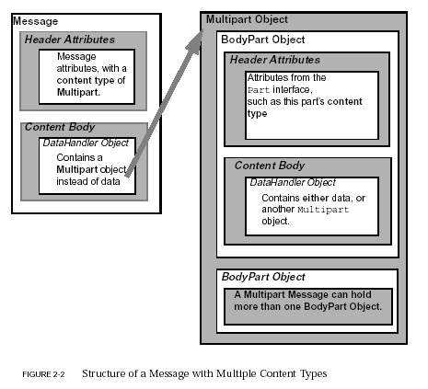
Message Transport
The JavaMail API provides the ability for users to send electronic mail messages. This chapter describes how to furnish a JavaMail service provider of a message transport system. If you are creating a JavaMail service provider that allows a client to access a mail server but does not handle sending mail, you do not have to implement this functionality.
To provide a message transport system, you must do the following:
- Provide a Transport implementation .
- Provide an Address subclass .
Transport
The function of the Transport class is to send (transport) messages; it is an abstract class.
To implement a specific transport protocol:
- Subclass the Transport class.
- Implement the Transport class’s abstract method, sendMessage.
- Override the default implementation of the Transport class’s protocolConnect method.

The Send Message Method
The Transport class provides static methods that applications use to send messages. The default implementations of these methods call the abstract method send Message to do the actual transmission. The send Message method has the following signature:
public abstract
void send Message(Message m, Address[] address)
throws Messaging Exception
Use the following procedure to implement the send Message method:
1. Check the type of the given message.
Typically, a service provider handles only certain types of messages. For example, an SMTP provider typically sends MimeMessages. In the face of an unknown message type, you can have sendMessage either fail and throw a MessagingException, or you can try to coerce it into a known type and send it.
2. Transmit the message.
Get the byte stream of the message, and transmit the message using its writeTo method.
3. Send a Transport Event.
The TransportEvent indicates the delivery status of the message. The possible event types are MESSAGE_DELIVERED, MESSAGE_NOT_DELIVERED, and MESSAGE_PARTIALLY_DELIVERED.
4. Throw an exception if the delivery is unsuccessful.
If the delivery fails, completely or partially, you must throw a suitable Messaging Exception or SendFailedException.
The Protocol Connect Method
The Transport class provides methods for applications to call that establish a connection with a transport. The methods, called connect, have default implementations that establish a connection by calling the protocolConnect method. You must override the protocolConnect method.
The signature of the protocolConnect method looks like this:
protected
boolean protocolConnect(String host, int port,String user, String password)

The method returns true if the connection and authentication succeed. If the connection fails, it throws a MessagingException. If the authentication fails, it returns false.
The default implementation of protocolConnect returns false, indicating that the authentication failed. You should provide an implementation that connects to the given host at the specified port, and performs the transport-specific authentication using the given username and password.
Address
The Address class is an abstract class. Subclasses provide specific implementations. Every Address subclass has a type-name, which identifies the address-type represented by that subclass. For example,
javax.mail.internet.InternetAddress subclass has the type-name: rfc822.
The type-name is used to map address-types to Transport protocols. These mappings are set in the address.map registry. For example, the default address.map in the JavaMail package contains the following entry: rfc822=smtp
The Address-type to Transport mapping is used by JavaMail to determine the Transport object to be used to send a message. The getTransport(Address) method on Session does this, by searching the address.map for the transportprotocol that corresponds to the type of the given address object. For example, invoking the getTransport(Address) method with an InternetAddress object, will return a Transport object that implements the SMTP protocol.
An Address subclass may also provide additional methods that are specific to that address-type. For example, one method that the InternetAddress class adds is the getAddress method.

DESIGN
Use case diagram
Student Registration
Attendance and Marks Updates

Sending SMS

Notice

The user after downloading the application the user is able to click registration button and there is a registration form available which upon completion one can submit to the QR Code server. After processing of the form the server can send a response back to the user if the request was successful.
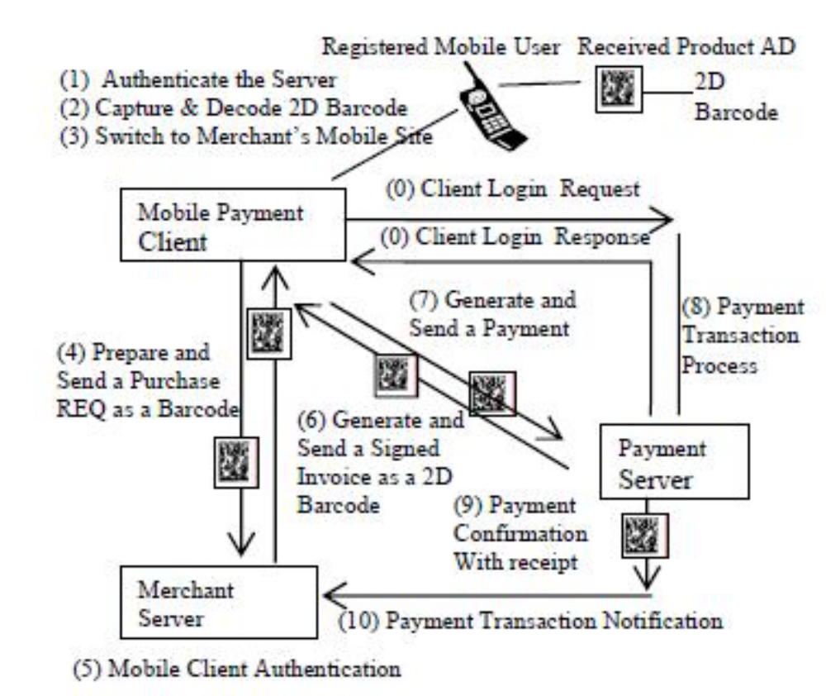

System Flowchart

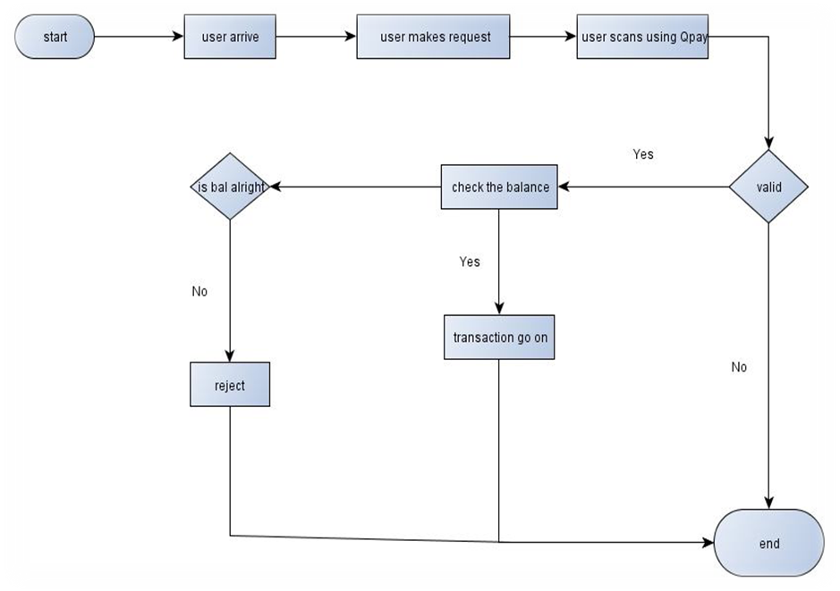

- Start: the whole action starts
- User arrives: the user arrives at the point of sale to purchase the goods.
- User makes request: user makes request by accessing the QR Code application by logging in.
- User scans: upon accessing the application the user scan the generated QR code which would have been generated by QR Code application.
- Check Balance: if the scanning is valid there is the checking of balance and if not, the system ends. If balance is ok then the transaction goes on but if there is no money then the transaction is stopped and the transaction is rejected. After all then the transaction then the whole process ends.

DFD (Dataflow Diagram)

Student Registration

Notice

Sending SMS

Attendance & Marks Updates

USER

Database

E-R DIAGRAM
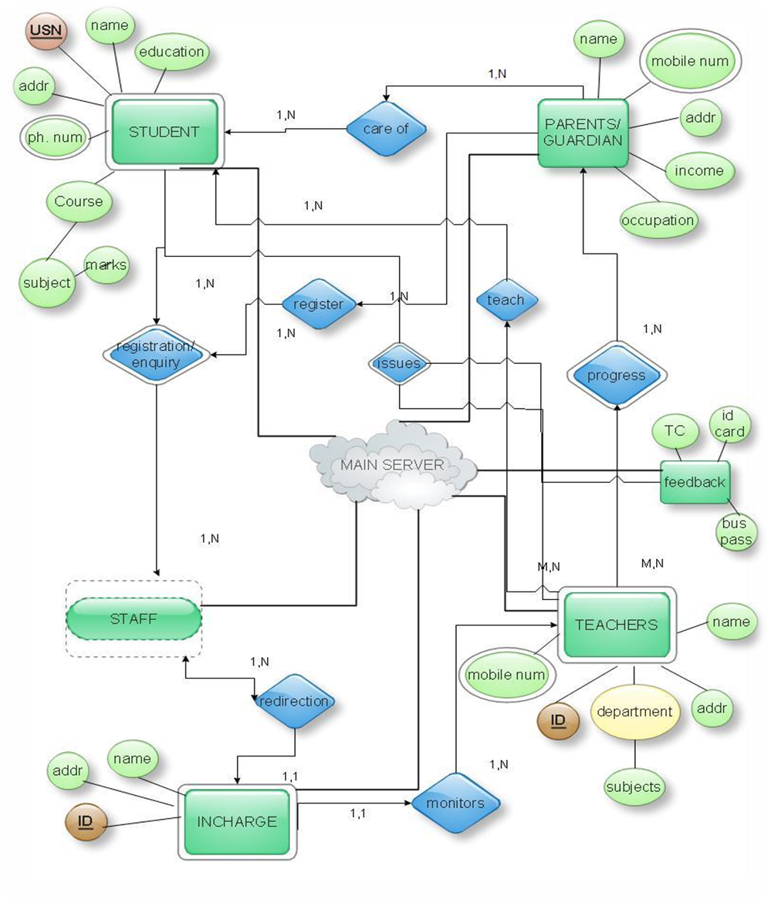

Entities
Student :
Attributes- This is a defining entity which comprises of all students in the institution.
- USN- It is the primary key/attribute which defines each student.
- Name- It can be used to login to the institution’s website and perform the required actions.
- Address- It can contain the current residential address or the permanent address or both.
- Phone number- This is a multi-valued attribute because a student can have more than one phone numbers to his/her name.
- Education- Educational details can be used for obtaining proof of the student’s academic background in case of issuing TCs etc.
- Course- It gives the course of the student has opted. The subjects the student has taken up are derived from this attribute.
- Marks- It is a comprehensive record of the student’s marks in internal tests/exams.

Parent/Guardian :
Attributes-
- Name- This is an entity defined by the Student entity.
- Address- This can be the same as the student’s address or different.
- Mobile number- This is a multi-valued attribute. SMS alerts are sent to this number which can be referenced from Student’s marks.

Teachers :
Attributes-
- ID- This is the primary key which uniquely identifies each teacher.
- Address- It can contain the current residential address or the permanent address or both.
- Mobile number- This is a multi-valued attribute. SMS alerts are sent to this number which can be referenced from Student’s marks and thus teacher’s performance can be evaluated.
- Name- It can be used to login to the institution’s website and perform the required actions.
- Department- This is the department the teacher belongs to. The course/courses teacher takes can be a sub-attribute of the same.
- Feedback- This entity can be used for generation of reports for students’ performance graphs, teachers’ performance graphs, College ID.

- Incharge- This is a strong entity which can have one or more people who are in charge of the whole administration. All the remaining staffs have to report to the Incharge.
- Staff- It is a weak entity which is referenced from the Incharge entity.

Relationships-
- A student is taught by a teacher or many teachers.
- A student is in care of his/her parents/guardian.
- A student has to register himself at the staff’s desk.
- A parent/guardian can keep track of his/her child’s progress by meeting the teachers.
- All staff have to report to the incharge.
- The incharge monitors the teachers and the staff.
- Feedback can be given for both teachers and students based on their marks.
- SMS alerts are sent to teachers and parents on their mobile numbers.

Coding
Qr code reader
package com.globalnest.qrcode;
import java.util.List;
import java.util.Map;
import com.google.zxing.BarcodeFormat;
import com.google.zxing.BinaryBitmap;
import com.google.zxing.ChecksumException;
import com.google.zxing.DecodeHintType;
import com.google.zxing.FormatException;
import com.google.zxing.NotFoundException;
import com.google.zxing.Reader;
import com.google.zxing.Result;
import com.google.zxing.ResultMetadataType;
import com.google.zxing.ResultPoint;
import com.google.zxing.common.BitMatrix;
import com.google.zxing.common.DecoderResult;
import com.google.zxing.common.DetectorResult;
import com.globalnest.decoder.Decoder;
import com.globalnest.detector.Detector;
/**
This implementation can detect and decode QR Codes in an image.
* */
public class QRCodeReader implements Reader {
private static final ResultPoint[ ] NO_POINTS = new ResultPoint[0];
private final Decoder decoder = new Decoder();

protected Decoder getDecoder() {
return decoder;
}
/**
* Locates and decodes a QR code in an image.
* @return a String representing the content encoded by the QR code
* @throws NotFoundException if a QR code cannot be found
* @throws FormatException if a QR code cannot be decoded
* @throws ChecksumException if error correction fails
*/
@Override
public Result decode(BinaryBitmap image) throws NotFoundException,
ChecksumException,
FormatException {
return decode(image, null);
}
@Override
public Result decode(BinaryBitmap image, Map<DecodeHintType, ?> hints)
throws NotFoundException, ChecksumException, FormatException {
DecoderResult decoderResult;
ResultPoint[ ] points;
if (hints != null && hints.containsKey(DecodeHintType.PURE_BARCODE)) {
BitMatrix bits = extractPureBits(image.getBlackMatrix());
decoderResult = decoder.decode(bits, hints);
points = NO_POINTS;
} else
{

DetectorResult detectorResult = new Detector(image.getBlackMatrix()).detect(hints);
decoderResult = decoder.decode(detectorResult.getBits(), hints);
points = detectorResult.getPoints();
}
Result result = new Result(decoderResult.getText(), decoderResult.getRawBytes(), points,
BarcodeFormat.QR_CODE);
List<byte[ ]> byteSegments = decoderResult.getByteSegments();
if (byteSegments != null) {
result.putMetadata(ResultMetadataType.BYTE_SEGMENTS, byteSegments);
}
String ecLevel = decoderResult.getECLevel();
if (ecLevel != null) {
result.putMetadata(ResultMetadataType.ERROR_CORRECTION_LEVEL, ecLevel);
}
return result;
}
@Override
public void reset() {
// do nothing
}
/**
* This method detects a code in a "pure" image -- that is, pure monochrome image
* which contains only an unrotated, unskewed, image of a code, with some white border
* around it. This is a specialized method that works exceptionally fast in this special
* case.
* @see com.google.zxing.pdf417.PDF417Reader#extractPureBits(BitMatrix)
* @see com.google.zxing.datamatrix.DataMatrixReader#extractPureBits(BitMatrix)

*/
private static BitMatrix extractPureBits(BitMatrix image) throws NotFoundException {
int[] leftTopBlack = image.getTopLeftOnBit();
int[] rightBottomBlack = image.getBottomRightOnBit();
if (leftTopBlack == null || rightBottomBlack == null) { throw NotFoundException
.getNotFoundInstance(); }
int moduleSize = moduleSize(leftTopBlack, image);
int top = leftTopBlack[1];
int bottom = rightBottomBlack[1];
int left = leftTopBlack[0];
int right = rightBottomBlack[0];
if (bottom - top != right - left) {
// Special case, where bottom-right module wasn't black so we found something else in
// the last row
// Assume it's a square, so use height as the width
right = left + (bottom - top);
}
int matrixWidth = (right - left + 1) / moduleSize;
int matrixHeight = (bottom - top + 1) / moduleSize;
if (matrixWidth <= 0 || matrixHeight <= 0) { throw NotFoundException.getNotFoundInstance(); }
if (matrixHeight != matrixWidth) {
// Only possibly decode square regions
throw NotFoundException.getNotFoundInstance();
}
// Push in the "border" by half the module width so that we start
// sampling in the middle of the module. Just in case the image is a

// little off, this will help recover.
int nudge = moduleSize >> 1;
top += nudge;
left += nudge;
// Now just read off the bits
BitMatrix bits = new BitMatrix(matrixWidth, matrixHeight);
for (int y = 0; y < matrixHeight; y++)

{
int iOffset = top + y * moduleSize;
for (int x = 0; x < matrixWidth; x++)
{
if (image.get(left + x * moduleSize, iOffset)) {
bits.set(x, y);
}
}
}
return bits;
}
private static int moduleSize(int[] leftTopBlack, BitMatrix image) throws NotFoundException {
int height = image.getHeight();
int width = image.getWidth();
int x = leftTopBlack[0];
int y = leftTopBlack[1];
while (x < width && y < height && image.get(x, y)) {
x++;
y++;

}
if (x == width || y == height) { throw NotFoundException.getNotFoundInstance(); }
int moduleSize = x - leftTopBlack[0];
if (moduleSize == 0) { throw NotFoundException.getNotFoundInstance(); }
return moduleSize;
}
}

QR code encoder

package com.globalnest.qrcode;
import android.provider.ContactsContract;
import android.graphics.Bitmap;
import android.os.Bundle;
import android.telephony.PhoneNumberUtils;
import java.util.Collection;
import java.util.EnumMap;
import java.util.HashSet;
import java.util.Map;
import com.globalnest.data.Contents;
import com.google.zxing.BarcodeFormat;
import com.google.zxing.EncodeHintType;
import com.google.zxing.MultiFormatWriter;
import com.google.zxing.WriterException;
import com.google.zxing.common.BitMatrix;

/**
* This class does the work of decoding the user's request and extracting all the data
* to be encoded in a barcode.
*
*/

public final class QRCodeEncoder
{
private static final int WHITE = 0xFFFFFFFF;
private static final int BLACK = 0xFF000000;
private int dimension = Integer.MIN_VALUE;
private String contents = null;
private String displayContents = null;
private String title = null;
private BarcodeFormat format = null;
private boolean encoded = false;
public QRCodeEncoder(String data, Bundle bundle, String type, String format, int
dimension)
{
this.dimension = dimension;
encoded = encodeContents(data, bundle, type, format);
}
public String getContents()
{
return contents;
}
public String getDisplayContents()
{
return displayContents;
}
public String getTitle()
{
return title;
}
private boolean encodeContents(String data, Bundle bundle, String type, String formatString)
{

// Default to QR_CODE if no format given.
format = null;
if (formatString != null)
{
try {
format = BarcodeFormat.valueOf(formatString);
}
catch (IllegalArgumentException iae) {
// Ignore it then
}
}
if (format == null || format == BarcodeFormat.QR_CODE) {
this.format = BarcodeFormat.QR_CODE;

encodeQRCodeContents(data, bundle, type);
}
else if (data != null && data.length() > 0)
{
contents = data;
displayContents = data;
title = "Text";
}
return contents != null && contents.length() > 0;
}
private void encodeQRCodeContents(String data, Bundle bundle, String type)
{
if (type.equals(Contents.Type.TEXT))
{
if (data != null && data.length() > 0)
{
contents = data;
displayContents = data;
title = "Text";
}
}

else if (type.equals(Contents.Type.EMAIL))
{
data = trim(data);
if (data != null)
{
contents = "mailto:" + data;
displayContents = data;
title = "E-Mail";
}
}
else if (type.equals(Contents.Type.PHONE)) {
data = trim(data);
if (data != null) {
contents = "tel:" + data;
displayContents = PhoneNumberUtils.formatNumber(data);

title = "Phone";
}
} else if (type.equals(Contents.Type.SMS)) {
data = trim(data);
if (data != null) {
contents = "sms:" + data;
displayContents = PhoneNumberUtils.formatNumber(data);
title = "SMS";
}
} else if (type.equals(Contents.Type.CONTACT)) {
if (bundle != null) {
StringBuilder newContents = new StringBuilder(100);
StringBuilder newDisplayContents = new StringBuilder(100);
newContents.append("MECARD:");
String name = trim(bundle.getString(ContactsContract.Intents.Insert.NAME));
if (name != null) {
newContents.append("N:").append(escapeMECARD(name)).append(';');
newDisplayContents.append(name);
}

String address = trim(bundle.getString(ContactsContract.Intents.Insert.POSTAL));
if (address != null) {
newContents.append("ADR:").append(escapeMECARD(address)).append(';');
newDisplayContents.append('\n').append(address);
}
Collection<String> uniquePhones = new
HashSet<String>(Contents.PHONE_KEYS.length);
for (int x = 0; x < Contents.PHONE_KEYS.length; x++) {
String phone = trim(bundle.getString(Contents.PHONE_KEYS[x]));
if (phone != null) {
uniquePhones.add(phone);
}
}
for (String phone : uniquePhones) {
newContents.append("TEL:").append(escapeMECARD(phone)).append(';');
newDisplayContents.append('\n').append(PhoneNumberUtils.formatNumber(phone));
}
Collection<String> uniqueEmails = new
HashSet<String>(Contents.EMAIL_KEYS.length);
for (int x = 0; x < Contents.EMAIL_KEYS.length; x++) {
String email = trim(bundle.getString(Contents.EMAIL_KEYS[x]));
if (email != null) {
uniqueEmails.add(email);
}
}
for (String email : uniqueEmails) {
newContents.append("EMAIL:").append(escapeMECARD(email)).append(';');
newDisplayContents.append('\n').append(email);
}
String url = trim(bundle.getString(Contents.URL_KEY));
if (url != null) {
// escapeMECARD(url) -> wrong escape e.g. http\://zxing.google.com
newContents.append("URL:").append(url).append(';');
newDisplayContents.append('\n').append(url);

}
String note = trim(bundle.getString(Contents.NOTE_KEY));
if (note != null) {
newContents.append("NOTE:").append(escapeMECARD(note)).append(';');
newDisplayContents.append('\n').append(note);
}
// Make sure we've encoded at least one field.
if (newDisplayContents.length() > 0) {
newContents.append(';');
contents = newContents.toString();
displayContents = newDisplayContents.toString();
title = "Contact";
} else {
contents = null;
displayContents = null;
}
}
} else if (type.equals(Contents.Type.LOCATION)) {
if (bundle != null) {
// These must use Bundle.getFloat(), not getDouble(), it's part of the API.
float latitude = bundle.getFloat("LAT", Float.MAX_VALUE);
float longitude = bundle.getFloat("LONG", Float.MAX_VALUE);
if (latitude != Float.MAX_VALUE && longitude != Float.MAX_VALUE) {
contents = "geo:" + latitude + ',' + longitude;
displayContents = latitude + "," + longitude;
title = "Location";
}
}
}
}
public Bitmap encodeAsBitmap() throws WriterException {
if (!encoded) return null;
Map<EncodeHintType, Object> hints = null;
String encoding = guessAppropriateEncoding(contents);
if (encoding != null) {

hints = new EnumMap<EncodeHintType, Object>(EncodeHintType.class);
hints.put(EncodeHintType.CHARACTER_SET, encoding);
}
MultiFormatWriter writer = new MultiFormatWriter();
BitMatrix result = writer.encode(contents, format, dimension, dimension, hints);
int width = result.getWidth();
int height = result.getHeight();
int[] pixels = new int[width * height];
// All are 0, or black, by default
for (int y = 0; y < height; y++) {
int offset = y * width;
for (int x = 0; x < width; x++) {
pixels[offset + x] = result.get(x, y) ? BLACK : WHITE;
}
}
Bitmap bitmap = Bitmap.createBitmap(width, height, Bitmap.Config.ARGB_8888);
bitmap.setPixels(pixels, 0, width, 0, 0, width, height);
return bitmap;
}
private static String guessAppropriateEncoding(CharSequence contents) {

// Very crude at the moment
for (int i = 0; i < contents.length(); i++) {
if (contents.charAt(i) > 0xFF) { return "UTF-8"; }
}
return null;
}
private static String trim(String s) {
if (s == null) { return null; }
String result = s.trim();
return result.length() == 0 ? null : result;
}
private static String escapeMECARD(String input) {
if (input == null || (input.indexOf(':') < 0 && input.indexOf(';') < 0)) { return input; }
int length = input.length();

StringBuilder result = new StringBuilder(length);
for (int i = 0; i < length; i++) {
char c = input.charAt(i);
if (c == ':' || c == ';') {
result.append('\\');
}
result.append(c);
}
return result.toString();
}
}

Qr code writer
package com.globalnest.qrcode;
import java.util.Map;
import com.google.zxing.BarcodeFormat;
import com.google.zxing.EncodeHintType;
import com.google.zxing.Writer;
import com.google.zxing.WriterException;
import com.google.zxing.common.BitMatrix;
import com.globalnest.decoder.ErrorCorrectionLevel;
import com.globalnest.encoder.ByteMatrix;
import com.globalnest.encoder.Encoder;

import com.globalnest.encoder.QRCode;
/**
* This object renders a QR Code as a BitMatrix 2D array of greyscale values.
*
*
*/
public final class QRCodeWriter implements Writer {
private static final int QUIET_ZONE_SIZE = 4;
@Override
public BitMatrix encode(String contents, BarcodeFormat format, int width, int height)

throws WriterException {
return encode(contents, format, width, height, null);
}
@Override
public BitMatrix encode(String contents, BarcodeFormat format, int width, int height,
Map<EncodeHintType, ?> hints) throws WriterException {
if (contents.length() == 0) { throw new IllegalArgumentException("Found empty contents"); }
if (format != BarcodeFormat.QR_CODE) { throw new IllegalArgumentException(
"Can only encode QR_CODE, but got " + format); }
if (width < 0 || height < 0) { throw new IllegalArgumentException(
"Requested dimensions are too small: " + width + 'x' + height); }
ErrorCorrectionLevel errorCorrectionLevel = ErrorCorrectionLevel.L;
if (hints != null) {
ErrorCorrectionLevel requestedECLevel = (ErrorCorrectionLevel) hints
.get(EncodeHintType.ERROR_CORRECTION);
if (requestedECLevel != null) {
errorCorrectionLevel = requestedECLevel;
}
}
QRCode code = new QRCode();
Encoder.encode(contents, errorCorrectionLevel, hints, code);
return renderResult(code, width, height);
}
// Note that the input matrix uses 0 == white, 1 == black, while the output matrix uses
// 0 == black, 255 == white (i.e. an 8 bit greyscale bitmap).
private static BitMatrix renderResult(QRCode code, int width, int height) {

ByteMatrix input = code.getMatrix();
if (input == null) { throw new IllegalStateException(); }
int inputWidth = input.getWidth();
int inputHeight = input.getHeight();
int qrWidth = inputWidth + (QUIET_ZONE_SIZE << 1);
int qrHeight = inputHeight + (QUIET_ZONE_SIZE << 1);

int outputWidth = Math.max(width, qrWidth);

int outputHeight = Math.max(height, qrHeight);
int multiple = Math.min(outputWidth / qrWidth, outputHeight / qrHeight);
// Padding includes both the quiet zone and the extra white pixels to accommodate the
// requested
// dimensions. For example, if input is 25x25 the QR will be 33x33 including the quiet zone.
// If the requested size is 200x160, the multiple will be 4, for a QR of 132x132. These will
// handle all the padding from 100x100 (the actual QR) up to 200x160.
int leftPadding = (outputWidth - (inputWidth * multiple)) / 2;
int topPadding = (outputHeight - (inputHeight * multiple)) / 2;
BitMatrix output = new BitMatrix(outputWidth, outputHeight);
for (int inputY = 0, outputY = topPadding; inputY < inputHeight; inputY++, outputY += multiple) {
// Write the contents of this row of the barcode
for (int inputX = 0, outputX = leftPadding; inputX < inputWidth; inputX++, outputX +=
multiple) {
if (input.get(inputX, inputY) == 1) {
output.setRegion(outputX, outputY, multiple, multiple);
}
}
}
return output
}
}

Camera
package com.globalnest.camera;
import android.hardware.Camera;
import android.os.Handler;
import android.os.Message;
import android.util.Log;
/**
* @author seshkanth
*
*/

final class AutoFocusCallback implements Camera.AutoFocusCallback {
private static final String TAG = AutoFocusCallback.class.getSimpleName();
private static final long AUTOFOCUS_INTERVAL_MS = 1500L;
private Handler autoFocusHandler;
private int autoFocusMessage;
void setHandler(Handler autoFocusHandler, int autoFocusMessage) {
this.autoFocusHandler = autoFocusHandler;
this.autoFocusMessage = autoFocusMessage;
}
@Override
public void onAutoFocus(boolean success, Camera camera) {
if (autoFocusHandler != null) {
Message message = autoFocusHandler.obtainMessage(autoFocusMessage,
success);
// Simulate continuous autofocus by sending a focus request every
// AUTOFOCUS_INTERVAL_MS milliseconds.
// Log.d(TAG, "Got auto-focus callback; requesting another");
autoFocusHandler.sendMessageDelayed(message, AUTOFOCUS_INTERVAL_MS);
autoFocusHandler = null;
} else {
Log.d(TAG, "Got auto-focus callback, but no handler for it");
}
}
}

Camera preview
package com.globalnest.camera;
import android.content.Context;
import android.graphics.Point;
import android.graphics.Rect;
import android.hardware.Camera;
import android.os.Handler;
import android.util.Log;
import android.view.SurfaceHolder;
import java.io.IOException;
import com.globalnest.data.Preferences;
import com.railway.ticketing.checker.PlanarYUVLuminanceSource;
/**
* This object wraps the Camera service object and expects to be the only one talking to it.
* implementation encapsulates the steps needed to take preview-sized images, which are used
*for both preview and decoding.
*/
public final class CameraManager {
private static final String TAG = CameraManager.class.getSimpleName();
private static final int MIN_FRAME_WIDTH = 240;
private static final int MIN_FRAME_HEIGHT = 240;
private static final int MAX_FRAME_WIDTH = 320; //480; //600;
private static final int MAX_FRAME_HEIGHT =360;// 400;
private final CameraConfigurationManager configManager;
Camera camera;
private Rect framingRect;
private Rect framingRectInPreview;
private boolean initialized;
private boolean previewing;
private int requestedFramingRectWidth;

private int requestedFramingRectHeight;
/**
* Preview frames are delivered here, which we pass on to the registered handler. Make sure
* to clear the handler so it will only receive one message.
*/
private final PreviewCallback previewCallback;
/** Autofocus callbacks arrive here, and are dispatched to the Handler which requested them. */
private final AutoFocusCallback autoFocusCallback;
public CameraManager(Context context) {
this.configManager = new CameraConfigurationManager(context);
previewCallback = new PreviewCallback(configManager);
autoFocusCallback = new AutoFocusCallback();
}
public CameraConfigurationManager getConfigurationManager() {
return configManager;
}
public Camera getCamera() {
return camera;
}
/**
* Opens the camera driver and initializes the hardware parameters.
*
* @param holder The surface object which the camera will draw preview frames into.

* @throws IOException Indicates the camera driver failed to open.
*/
public void openDriver(SurfaceHolder holder) throws IOException {
Camera theCamera = camera;
if (theCamera == null) {
theCamera = Camera.open();
if (theCamera == null) { throw new IOException(); }
camera = theCamera;
}
theCamera.setPreviewDisplay(holder);
if (!initialized) {
initialized = true;
configManager.initFromCameraParameters(theCamera);
if (requestedFramingRectWidth > 0 && requestedFramingRectHeight > 0) {
setManualFramingRect(requestedFramingRectWidth,
requestedFramingRectHeight);
requestedFramingRectWidth = 0;
requestedFramingRectHeight = 0;
}
}
configManager.setDesiredCameraParameters(theCamera);
}

/**
* Closes the camera driver if still in use.
*/
public void closeDriver() {
if (camera != null) {
camera.release();
camera = null;
// Make sure to clear these each time we close the camera, so that any scanning rect
// requested by intent is forgotten.
framingRect = null;
framingRectInPreview = null;
}
}
/**
* Asks the camera hardware to begin drawing preview frames to the screen
*/
public void startPreview() {
Camera theCamera = camera;
if (theCamera != null && !previewing) {
theCamera.startPreview();
previewing = true;
}
}

/**
* Tells the camera to stop drawing preview frames.
*/
public void stopPreview() {
if (camera != null && previewing) {
camera.stopPreview();
previewCallback.setHandler(null, 0);
autoFocusCallback.setHandler(null, 0);
previewing = false;
}
}
/**
* A single preview frame will be returned to the handler supplied. The data will arrive as
* byte[]
* in the message.obj field, with width and height encoded as message.arg1 and message.arg2,
* respectively.
* @param handler The handler to send the message to.
* @param message The what field of the message to be sent.
*/
public void requestPreviewFrame(Handler handler, int message) {
Camera theCamera = camera;
if (theCamera != null && previewing) {
previewCallback.setHandler(handler, message);

theCamera.setOneShotPreviewCallback(previewCallback);
}
}
/**
* Asks the camera hardware to perform an autofocus.
* @param handler The Handler to notify when the autofocus completes.
* @param message The message to deliver.
*/
public void requestAutoFocus(Handler handler, int message) {
if (camera != null && previewing) {
autoFocusCallback.setHandler(handler, message);
camera.autoFocus(autoFocusCallback);
}
}
/**
* Calculates the framing rect which the UI should draw to show the user where to place
* the barcode. This target helps with alignment as well as forces the user to hold the
* device far enough away to ensure the image will be in focus.
* @return The rectangle to draw on screen in window coordinates.
*/
public Rect getFramingRect() {
if (framingRect == null) {
if (camera == null) { return null; }

Point screenResolution = configManager.getScreenResolution();
int width = screenResolution.x * 3 / 4;
if (width < MIN_FRAME_WIDTH) {
width = MIN_FRAME_WIDTH;
} else if (width > MAX_FRAME_WIDTH) {

width = MAX_FRAME_WIDTH;
}
int height = screenResolution.y * 3 / 4;
if (height < MIN_FRAME_HEIGHT) {
height = MIN_FRAME_HEIGHT;
} else if (height > MAX_FRAME_HEIGHT) {
height = MAX_FRAME_HEIGHT;
}
int leftOffset = (screenResolution.x - width) / 2;
int topOffset = (screenResolution.y - height) / 2;
framingRect = new Rect(leftOffset, topOffset, leftOffset + width, topOffset + height);
Log.d(TAG, "Calculated framing rect: " + framingRect);
}
return framingRect;
}
/**
* Like {@link #getFramingRect} but coordinates are in terms of the preview frame,

* not UI / screen.
*/
public Rect getFramingRectInPreview() {
if (framingRectInPreview == null) {
Rect framingRect = getFramingRect();
if (framingRect == null) { return null; }
Rect rect = new Rect(framingRect);
Point cameraResolution = configManager.getCameraResolution();
Point screenResolution = configManager.getScreenResolution();
/*
rect.left = rect.left * cameraResolution.y / screenResolution.x;
rect.right = rect.right * cameraResolution.y / screenResolution.x;
rect.top = rect.top * cameraResolution.x / screenResolution.y;
rect.bottom = rect.bottom * cameraResolution.x / screenResolution.y;
*/
rect.left = rect.left * cameraResolution.x / screenResolution.x;
rect.right = rect.right * cameraResolution.x / screenResolution.x;
rect.top = rect.top * cameraResolution.y / screenResolution.y;
rect.bottom = rect.bottom * cameraResolution.y / screenResolution.y;
framingRectInPreview = rect;
}
return framingRectInPreview;
}

/**
* Allows third party apps to specify the scanning rectangle dimensions, rather than
*determine them automatically based on screen resolution.
* @param width The width in pixels to scan.
* @param height The height in pixels to scan.
*/
public void setManualFramingRect(int width, int height) {
if (initialized) {
Point screenResolution = configManager.getScreenResolution();
if (width > screenResolution.x) {
width = screenResolution.x;
}
if (height > screenResolution.y) {
height = screenResolution.y;
}
int leftOffset = (screenResolution.x - width) / 2;
int topOffset = (screenResolution.y - height) / 2;
framingRect = new Rect(leftOffset, topOffset, leftOffset + width, topOffset + height);
Log.d(TAG, "Calculated manual framing rect: " + framingRect);
framingRectInPreview = null;
} else {
requestedFramingRectWidth = width;
requestedFramingRectHeight = height;

}
}
/**
* A factory method to build the appropriate LuminanceSource object based on the format
* of the preview buffers, as described by Camera.Parameters.
* @param data A preview frame.
* @param width The width of the image.
* @param height The height of the image.
* @return A PlanarYUVLuminanceSource instance.
*/
public PlanarYUVLuminanceSource buildLuminanceSource(byte[] data, int width, int height) {
Rect rect = getFramingRectInPreview();
if (rect == null) { return null; }
// Go ahead and assume it's YUV rather than die.
return new PlanarYUVLuminanceSource(data, width, height, rect.left, rect.top, rect.width(), rect.height(), Preferences.KEY_REVERSE_IMAGE);
}
}

Camera data
package com.globalnest.data;
import android.provider.ContactsContract;
/**
* The set of constants to use when sending Barcode Scanner an Intent which requests a
* barcode to be encoded.
*/
public final class Contents {
private Contents() {
}
public static final class Type {
/**
* Plain text. Use Intent.putExtra(DATA, string). This can be used for URLs too, but string
* must include "http://" or "https://".
*/
public static final String TEXT = "TEXT_TYPE";
/**
* An email type. Use Intent.putExtra(DATA, string) where string is the email address.
*/
public static final String EMAIL = "EMAIL_TYPE";
/**
* Use Intent.putExtra(DATA, string) where string is the phone number to call.
*/
public static final String PHONE = "PHONE_TYPE";
/**
* An SMS type. Use Intent.putExtra(DATA, string) where string is the number to SMS.
*/
public static final String SMS = "SMS_TYPE";
/**
* A contact. Send a request to encode it as follows:
* <p/>
* import android.provider.Contacts;
* <p/>

* Intent intent = new Intent(Intents.Encode.ACTION);
intent.putExtra(Intents.Encode.TYPE,
* CONTACT); Bundle bundle = new Bundle();
bundle.putString(Contacts.Intents.Insert.NAME,
* "Jenny"); bundle.putString(Contacts.Intents.Insert.PHONE, "8675309");
* bundle.putString(Contacts.Intents.Insert.EMAIL, "jenny@the80s.com");
* bundle.putString(Contacts.Intents.Insert.POSTAL, "123 Fake St. San Francisco, CA
94102");
* intent.putExtra(Intents.Encode.DATA, bundle);
*/
public static final String CONTACT = "CONTACT_TYPE";
/**
* A geographic location. Use as follows:
* Bundle bundle = new Bundle();
* bundle.putFloat("LAT", latitude);
* bundle.putFloat("LONG", longitude);
* intent.putExtra(Intents.Encode.DATA, bundle);
*/
public static final String LOCATION = "LOCATION_TYPE";
private Type() {
}
}
public static final String URL_KEY = "URL_KEY";
public static final String NOTE_KEY = "NOTE_KEY";
/**
* When using Type.CONTACT, these arrays provide the keys for adding or retrieving
* multiple phone numbers and addresses.
*/
public static final String[] PHONE_KEYS = {
ContactsContract.Intents.Insert.PHONE,
ContactsContract.Intents.Insert.SECONDARY_PHONE,
ContactsContract.Intents.Insert.TERTIARY_PHONE
};
public static final String[] PHONE_TYPE_KEYS = {
ContactsContract.Intents.Insert.PHONE_TYPE,

ContactsContract.Intents.Insert.SECONDARY_PHONE_TYPE,
ContactsContract.Intents.Insert.TERTIARY_PHONE_TYPE
};
public static final String[] EMAIL_KEYS = {
ContactsContract.Intents.Insert.EMAIL,
ContactsContract.Intents.Insert.SECONDARY_EMAIL,
ContactsContract.Intents.Insert.TERTIARY_EMAIL
};
public static final String[] EMAIL_TYPE_KEYS = {
ContactsContract.Intents.Insert.EMAIL_TYPE,
ContactsContract.Intents.Insert.SECONDARY_EMAIL_TYPE,
ContactsContract.Intents.Insert.TERTIARY_EMAIL_TYPE
};
}

Login page
Java
package com.attendance;
import java.io.ObjectInputStream;
import java.io.ObjectOutputStream;
import java.net.Socket;
import android.os.Bundle;
import android.app.Activity;
import android.content.Context;
import android.content.Intent;
import android.database.Cursor;
import android.database.sqlite.SQLiteDatabase;
import android.telephony.TelephonyManager;

import android.view.Menu;
import android.view.MenuItem;
import android.view.View;
import android.view.View.OnClickListener;
import android.widget.Button;
import android.widget.EditText;
import android.widget.TextView;
import android.widget.Toast
public class Login extends Activity {
Button b1,b2;
EditText e1,e2;
EditText e3;
Socket ss;
ObjectInputStream ois;
ObjectOutputStream oos;
public void onCreate(Bundle savedInstanceState) {
super.onCreate(savedInstanceState);
setContentView(R.layout.activity_login);
e1=(EditText)findViewById(R.id.editText1);
e2=(EditText)findViewById(R.id.editText2);
b1=(Button)findViewById(R.id.button1);
b2=(Button)findViewById(R.id.button2);
// e1.setText("daya");

// e2.setText("daya");
// TelephonyManager telephonyManager =
(TelephonyManager)getSystemService(Context.TELEPHONY_SERVICE);
// String imei = telephonyManager.getDeviceId
// if((!imei.contains("911304153844521"))){
// TextView tv=null;
// tv.setText("");
// }
b1.setOnClickListener(new OnClickListener() {

@Override
public void onClick(View v)
{
MatchUser();
}
});
b2.setOnClickListener(new OnClickListener() {
@Override
public void onClick(View v) {
Intent intent = new Intent(Login.this,Register.class);
startActivity(intent);
}
});
}

public void MatchUser(){
Database dat = new Database(getBaseContext());
SQLiteDatabase db = dat.getWritableDatabase();
Cursor c = db.rawQuery("select * from Faculty where
Username='"+e1.getText().toString()+"' and Password='"+e2.getText().toString()+"'", null);
if(c.getCount()!=0){
c.moveToFirst();
Toast.makeText(getApplicationContext(), "Login successfull.", 6000).show();
finish();
Register.mSubjectVal = c.getString(c.getColumnIndex("Subject"));
Intent intent = new Intent(Login.this,MainActivity.class);
startActivity(intent);
}
else
{
Toast.makeText(getApplicationContext(), "Invalid credentials", 6000).show();
}
c.close();
db.close();
}
}

Xml
<RelativeLayout xmlns:android="http://schemas.android.com/apk/res/android"
xmlns:tools="http://schemas.android.com/tools"
android:layout_width="match_parent"
android:layout_height="match_parent"
>
<Button
android:id="@+id/button1"
android:layout_width="wrap_content"
android:layout_height="wrap_content"
android:layout_alignParentBottom="true"
android:layout_alignParentLeft="true"
android:layout_centerVertical="true"
android:layout_margin="80dp"
android:layout_marginBottom="400dp"
android:text="LOGIN" />
<EditText
android:id="@+id/editText2"
android:layout_width="wrap_content"
android:layout_height="wrap_content"
android:layout_alignParentRight="true"
android:layout_centerVertical="true"
android:ems="10"
android:inputType="textPassword" />
<TextView
android:id="@+id/textView1"
android:layout_width="wrap_content"
android:layout_height="wrap_content"
android:layout_alignBaseline="@+id/editText1"
android:layout_alignBottom="@+id/editText1"
android:layout_alignParentLeft="true"
android:text="USERNAME"
/>

<TextView
android:id="@+id/textView3"
android:layout_width="wrap_content"
android:layout_height="wrap_content"
android:layout_alignParentLeft="true"
android:layout_centerVertical="true"
android:text="PASSWORD" />
<EditText
android:id="@+id/editText1"
android:layout_width="wrap_content"
android:layout_height="wrap_content"
android:layout_above="@+id/editText2"
android:layout_alignParentRight="true"
android:layout_marginBottom="44dp"
android:ems="10" />
<Button
android:id="@+id/button2"
android:layout_width="wrap_content"
android:layout_height="wrap_content"
android:layout_alignBaseline="@+id/button1"
android:layout_alignBottom="@+id/button1"
android:layout_alignLeft="@+id/editText1"
android:layout_marginLeft="67dp"
android:text="Register" />
</RelativeLayout>

Register
java
package com.attendance;
import android.app.Activity;
import android.content.ContentValues;
import android.database.Cursor;
import android.database.sqlite.SQLiteDatabase;
import android.os.Bundle;
import android.view.View;
import android.view.View.OnClickListener;
import android.widget.Button;

import android.widget.EditText;
import android.widget.Toast;
public class Register extends Activity {
EditText mUserid,mPassword,mName,mSubject,mPhone;
Button mSubmit;
static String mSubjectVal;
@Override
public void onCreate(Bundle savedInstanceState){
super.onCreate(savedInstanceState);
setContentView(R.layout.register);
mUserid = (EditText) findViewById(R.id.editText1);
mPassword = (EditText) findViewById(R.id.editText2);
mName = (EditText) findViewById(R.id.editText3);
mSubject = (EditText) findViewById(R.id.editText4);
mPhone = (EditText) findViewById(R.id.editText5);
mSubmit = (Button) findViewById(R.id.button1);
mSubmit.setOnClickListener(new OnClickListener() {
@Override
public void onClick(View v) {
// TODO Auto-generated method stub
String[] subs = mSubject.getText().toString().split("\\,");

if(subs.length!=3){
Toast.makeText(getApplicationContext(), "Subject must be 3", 60000).show();
}else{
Insertdata();
finish();
}
}
});
}
public void Insertdata(){
ContentValues cv = new ContentValues();
cv.put("Username", mUserid.getText().toString());
cv.put("Password", mPassword.getText().toString());
cv.put("Name", mName.getText().toString());
cv.put("MobileNo", mPhone.getText().toString());
cv.put("Subject", mSubject.getText().toString());
Database dat = new Database(getBaseContext());
SQLiteDatabase db = dat.getWritableDatabase();
Cursor c = db.rawQuery("select * from Faculty where Username='"+mUserid.getText().toString()+"'", null);
if(c.getCount()!=0){
Toast.makeText(getApplicationContext(), "User Already exists.", 6000).show();
}else{
Toast.makeText(getApplicationContext(), "registration success full", 60000).show();
db.insert("Faculty", null, cv);
}
db.close();
}
}

Xml
<?xml version="1.0" encoding="utf-8"?>
<LinearLayout xmlns:android="http://schemas.android.com/apk/res/android"
android:layout_width="match_parent"
android:layout_height="match_parent"
android:orientation="vertical" >
<EditText
android:id="@+id/editText1"
android:layout_width="match_parent"
android:layout_height="wrap_content"
android:hint="Enter username"
android:ems="10" >
<requestFocus />
</EditText>
<EditText
android:id="@+id/editText2"
android:hint="Enter password"
android:inputType="textPassword"
android:layout_width="match_parent"
android:layout_height="wrap_content"
android:ems="10" />
<EditText
android:id="@+id/editText3"
android:layout_width="match_parent"
android:hint="Enter name"
android:layout_height="wrap_content"
android:ems="10" />
<EditText
android:id="@+id/editText4"
android:layout_width="match_parent"
android:hint="Enter subjects wiht comma separated"
android:layout_height="wrap_content"
android:ems="10" />

<EditText
android:id="@+id/editText5"
android:hint="Enter phone"
android:inputType="phone"
android:layout_width="match_parent"
android:layout_height="wrap_content"
android:ems="10" />
<Button
android:id="@+id/button1"
android:layout_width="wrap_content"
android:layout_height="wrap_content"
android:text="Submit" />
</LinearLayout>

Attendance
package com.attendance;
import android.app.Activity;
import android.content.Intent;
import android.os.Bundle;
import android.view.View;
import android.view.View.OnClickListener;
import android.widget.Button;
import android.widget.EditText;
import android.widget.Toast;
public class MainActivity1 extends Activity {
EditText mSem;
@Override
protected void onCreate(Bundle savedInstanceState) {

super.onCreate(savedInstanceState);
setContentView(R.layout.attdbackup);
mSem = (EditText) findViewById(R.id.sem);
Button btn = (Button) findViewById(R.id.button1);
Button btn1 = (Button) findViewById(R.id.button2);
Button btn2 = (Button) findViewById(R.id.button3);
Button btn3 = (Button) findViewById(R.id.button4);
btn3.setOnClickListener(new OnClickListener() {
@Override
public void onClick(View arg0) {
// TODO Auto-generated method stub
Intent intent = new Intent(MainActivity1.this,AndroidTimeActivity.class);
startActivity(intent);
}
});
btn2.setOnClickListener(new OnClickListener()
@Override
public void onClick(View arg0) {
// TODO Auto-generated method stub
if(mSem.getText().toString().equals("")){
Toast.makeText(getApplicationContext(), "Please enter sem", 60000).show();
}else{
Intent intent = new Intent(MainActivity1.this,List.class);

intent.putExtra("sem", mSem.getText().toString());
startActivity(intent);
}
});
btn.setOnClickListener(new OnClickListener() {
@Override
public void onClick(View arg0) {
// TODO Auto-generated method stub
if(mSem.getText().toString().equals("")){
Toast.makeText(getApplicationContext(), "Please enter sem", 60000).show();
}else{
Intent intent = new Intent(MainActivity1.this,Student.class);
intent.putExtra("sem", mSem.getText().toString());
startActivity(intent);
}
}
});
btn1.setOnClickListener(new OnClickListener() {
@Override
public void onClick(View arg0) {
// TODO Auto-generated method stub
if(mSem.getText().toString().equals("")){
Toast.makeText(getApplicationContext(), "Please enter sem", 60000).show();

}else{
Intent intent = new Intent(MainActivity1.this,AttendanceschoolActivity.class);
intent.putExtra("sem", mSem.getText().toString());
startActivity(intent);
}
}
});
}
}
Xml
<LinearLayout xmlns:android="http://schemas.android.com/apk/res/android"
android:layout_width="wrap_content"
android:layout_height="match_parent"
android:layout_gravity="center"
android:orientation="vertical"
android:gravity="center"
android:background="@drawable/bg"
>
<EditText
android:layout_width="wrap_content"
android:layout_height="wrap_content"
android:id="@+id/sem"
android:hint="Enter sem"
android:inputType="number"
/>
<Button
android:id="@+id/button1"
android:layout_width="150dip"
android:layout_height="wrap_content"
android:text="Add Student"

/>
<Button
android:id="@+id/button2"
android:layout_width="150dip"
android:layout_height="wrap_content"
android:layout_marginTop="15dip"
android:text="Get Attendance" />
<Button
android:id="@+id/button3"
android:layout_width="150dip"
android:layout_height="wrap_content"
android:layout_below="@+id/button2"
android:layout_centerHorizontal="true"
android:layout_marginTop="15dip"
android:text="View Details"
/>
<Button
android:id="@+id/button4"
android:layout_width="150dip"
android:layout_height="wrap_content"
android:layout_below="@+id/button3"
android:layout_centerHorizontal="true"
android:layout_marginTop="15dip"
android:text="Reminder"
android:visibility="gone"
/>
</LinearLayout>

Student DataBase
java
package com.attendance;
import android.app.Activity;
import android.app.AlertDialog;
import android.content.ContentValues;
import android.content.DialogInterface;
import android.content.Intent;
import android.database.Cursor;
import android.database.sqlite.SQLiteDatabase;
import android.os.Bundle;
import android.telephony.SmsManager;
import android.view.View;
import android.view.View.OnClickListener;
import android.widget.Button;
import android.widget.EditText;
import android.widget.Toast;
public class Student extends Activity {
String sem;
@Override
protected void onCreate(Bundle savedInstanceState) {
super.onCreate(savedInstanceState);
setContentView(R.layout.student);

String data = getIntent().getStringExtra("edit");
sem = getIntent().getStringExtra("sem");
final EditText usn = (EditText) findViewById(R.id.editText1);
final EditText name = (EditText) findViewById(R.id.editText2);
final EditText Fname = (EditText) findViewById(R.id.editText3);
final EditText fees = (EditText) findViewById(R.id.editText4);
final EditText sem = (EditText) findViewById(R.id.editText5);
final EditText sex = (EditText) findViewById(R.id.editText6);
final EditText fnumber = (EditText) findViewById(R.id.editText7);
final EditText snumber = (EditText) findViewById(R.id.editText8);
final EditText bg = (EditText) findViewById(R.id.editText9);
sem.setVisibility(View.GONE);
if(data!=null){
String[] temp = Entermarks.studentData.split("\n");
usn.setText(temp[0]);
name.setText(temp[1]);
Fname.setText(temp[2]);
fees.setText(temp[3]);
sem.setText(temp[4]);
sex.setText(temp[5]);
fnumber.setText(temp[6]);
snumber.setText(temp[7]);
Student.this.sem = temp[4];

}else{
}
Button submit = (Button) findViewById(R.id.button1);
submit.setOnClickListener(new OnClickListener() {
@Override
public void onClick(View v) {
// TODO Auto-generated method stub
if(usn.getText().toString().equals("")){
Toast.makeText(getApplicationContext(), "Usn and Password should not be empty", 60000).show();
}else{
ContentValues cv = new ContentValues();
cv.put("USN", usn.getText().toString());
cv.put("Name", name.getText().toString());
cv.put("FatherName", Fname.getText().toString());
cv.put("Fees", fees.getText().toString());
cv.put("Sem", Student.this.sem);
cv.put("Sex", sex.getText().toString());
cv.put("FatherNumber", fnumber.getText().toString());
cv.put("StudentNumber", snumber.getText().toString());
cv.put("BloodGroup", bg.getText().toString());
//cv.put("Password", password.getText().toString());
Database dat = new Database(getBaseContext());
SQLiteDatabase db = dat.getWritableDatabase();

Cursor c = db.rawQuery("select * from Student where
USN='"+usn.getText().toString()+"'", null);
if(c.getCount()!=0){
db.update("Student", cv, "USN='"+usn.getText().toString()+"'", null);
Toast.makeText(getApplicationContext(), "Usn already exists, Date Updated.",
6000).show();
}else{
if(fnumber.getText().toString().length()<10||snumber.getText().toString().length()<1
0||usn.getText().toString().length()<5){
Toast.makeText(getApplicationContext(), "Either father no or student no or usn
should not be less than 10 characters", Toast.LENGTH_LONG).show();
}else{
db.insert("Student", null, cv);
Toast.makeText(getApplicationContext(), "Student inserted", 6000).show();
alertDialogtwoButton();
}
}
c.close();
db.close();
}
}
});
}

public void alertDialogtwoButton(){
alertDialog.setTitle("Warning!");
alertDialog.setMessage("Would like to register another Student");
alertDialog.setButton("YES", new DialogInterface.OnClickListener() {
@Override
public void onClick(DialogInterface dialog, int which) {
// TODO Auto-generated method stub
finish();
Intent intent = new Intent(Student.this,Student.class);
startActivity(intent);
alertDialog.setButton2("NO", new DialogInterface.OnClickListener() {
public void onClick(DialogInterface dialog, int id) {
finish();
}
});
alertDialog.show();
}
}

Testing
The purpose of testing is to discover errors. Testing is the process of trying to discover every conceivable fault or weakness in a work product. It provides a way to check the functionality of components, sub assemblies, assemblies and/or a finished product It is the process of exercising software with the intent of ensuring that the Software system meets its requirements and user expectations and does not fail in an unacceptable manner. There are various types of test. Each test type addresses a specific testing requirement.

Types of Tests

Unit testing
Unit testing involves the design of test cases that validate that the internal program logic is functioning properly, and that program input produce valid outputs. All decision branches and internal code flow should be validated. It is the testing of individual software units of the application .it is done after the completion of an individual unit before integration. This is a structural testing, that relies on knowledge of its construction and is invasive. Unit tests perform basic tests at component level and test a specific business process, application, and/or system configuration. Unit tests ensure that each unique path of a business process performs accurately to the documented specifications and contains clearly defined inputs and expected results.

Functional testing
Functional tests provide systematic demonstrations that functions tested are available as specified by the business and technical requirements, system documentation, and user manuals.
Functional testing is centered on the following items:
Valid Input : identified classes of valid input must be accepted.
Invalid Input : identified classes of invalid input must be rejected.
Functions : identified functions must be exercised.
Output : identified classes of application outputs must be exercised.
Systems/Procedures: interfacing systems or procedures must be invoked.
System Testing
System testing ensures that the entire integrated software system meets requirements. It tests a configuration to ensure known and predictable results.

Performance Testing
The Performance test ensures that the output be produced within the time limits,and the time taken by the system for compiling, giving response to the users and request being send to the system for to retrieve the results.

Integration Testing
Software integration testing is the incremental integration testing of two or more integrated software components on a single platform to produce failures caused by interface defects. The task of the integration test is to check that components or software applications, e.g. components in a software system or – one step up – software applications at the company level – interact without error.
Integration testing for Server Synchronization:
- Testing the IP Address for to communicate with the other Nodes .
- Check the Route status in the Cache Table after the status information is received by the Node.
- The Messages are displayed throughout the end of the application.

Acceptance Testing
User Acceptance Testing is a critical phase of any project and requires significant participation by the end user. It also ensures that the system meets the functional requirements.
Acceptance testing for Data Synchronization:
- The Acknowledgements will be received by the Sender Node after the Packets are received by the Destination Node.
- The Route add operation is done only when there is a Route request in need.
- The Status of Nodes information is done automatically in the Cache Updation process.

APPLICATIONS:
- Individual profile for each student and teacher in the institution which can be accessed using the USN (student) or the employee number (teacher) to check performances, attendance, status of pending requests and to upload documents.
- SMS alerts which are to be sent to parents of pupils which contain the their child’s performance details and also institution faculty contact numbers which are to be used in case the parent wants any further clarifications.
- QR code is used to scan and the attendance.
- Information regarding memo are given to students as well as teachers.
- Notes sharing is provided in case, the student is absent.

Snapshots
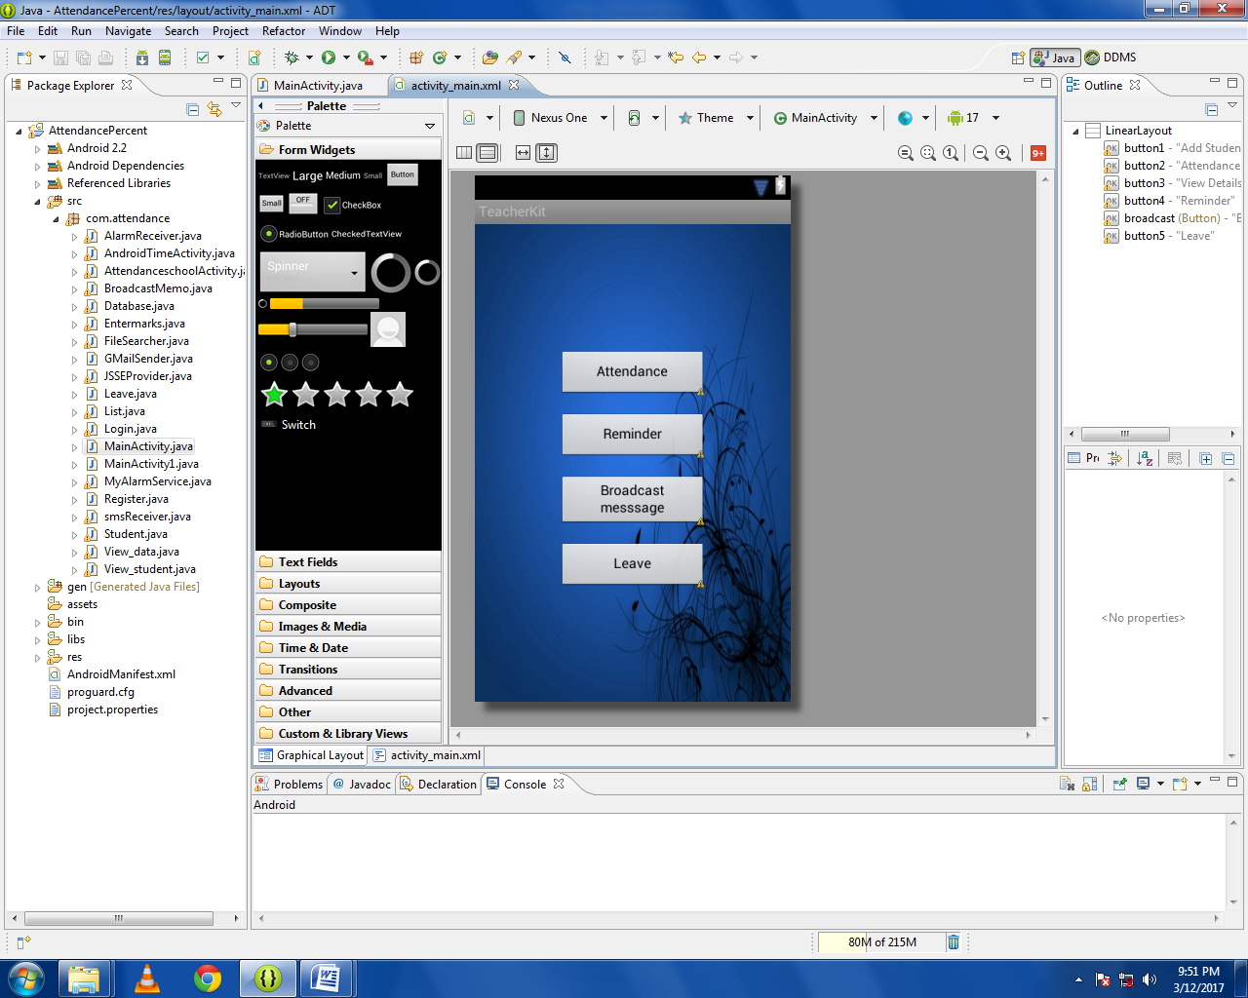

LOGIN
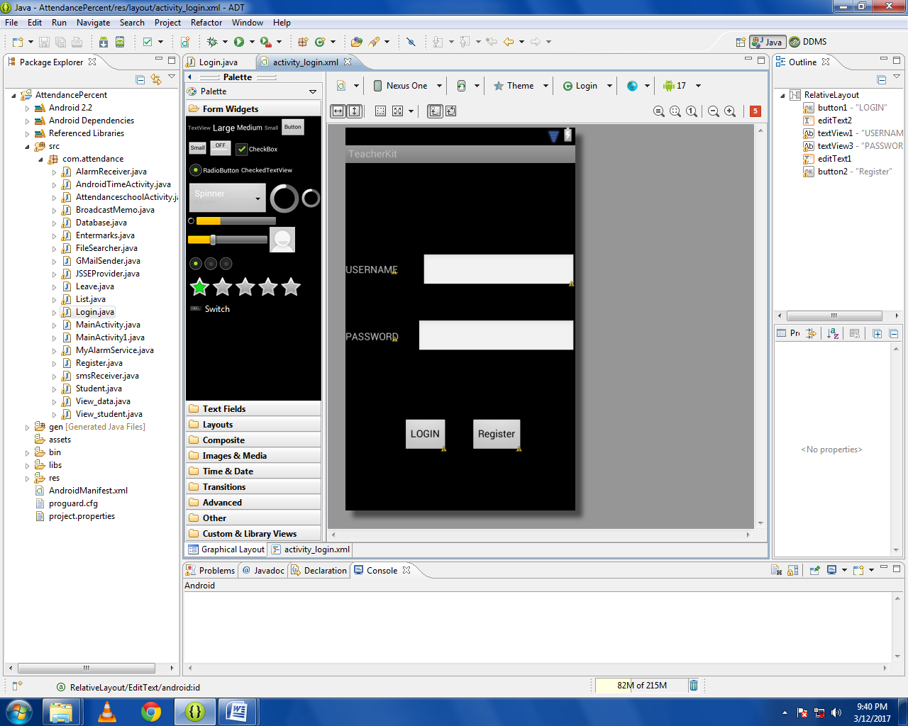

REGISTER
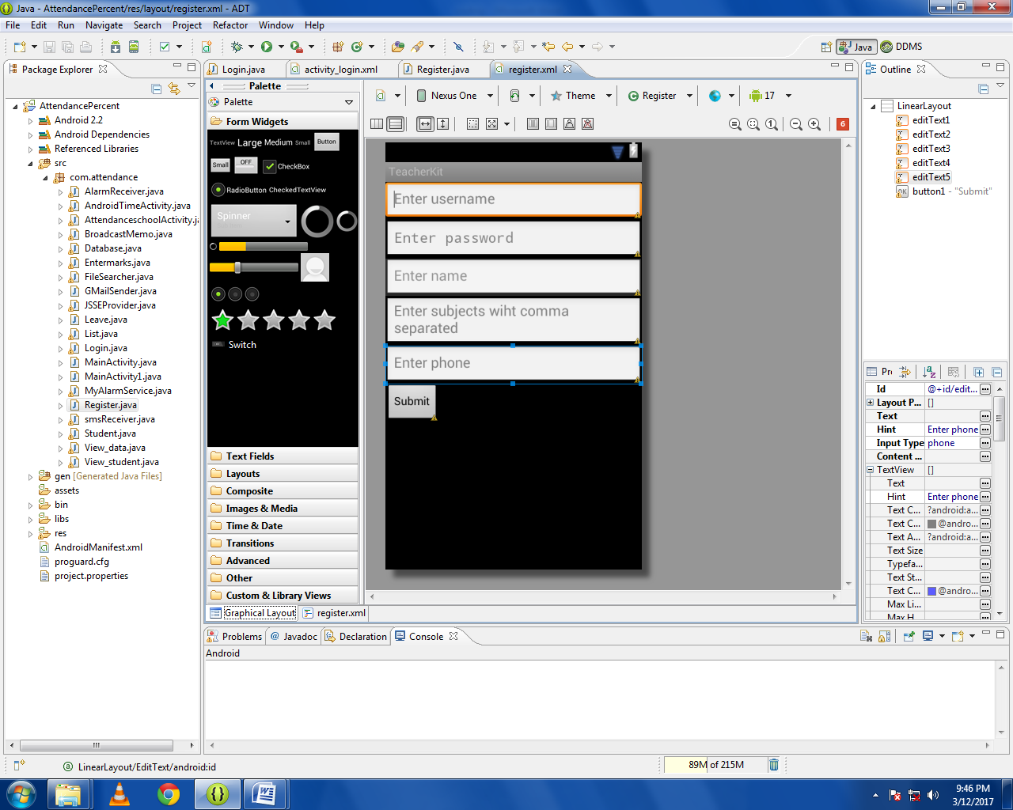

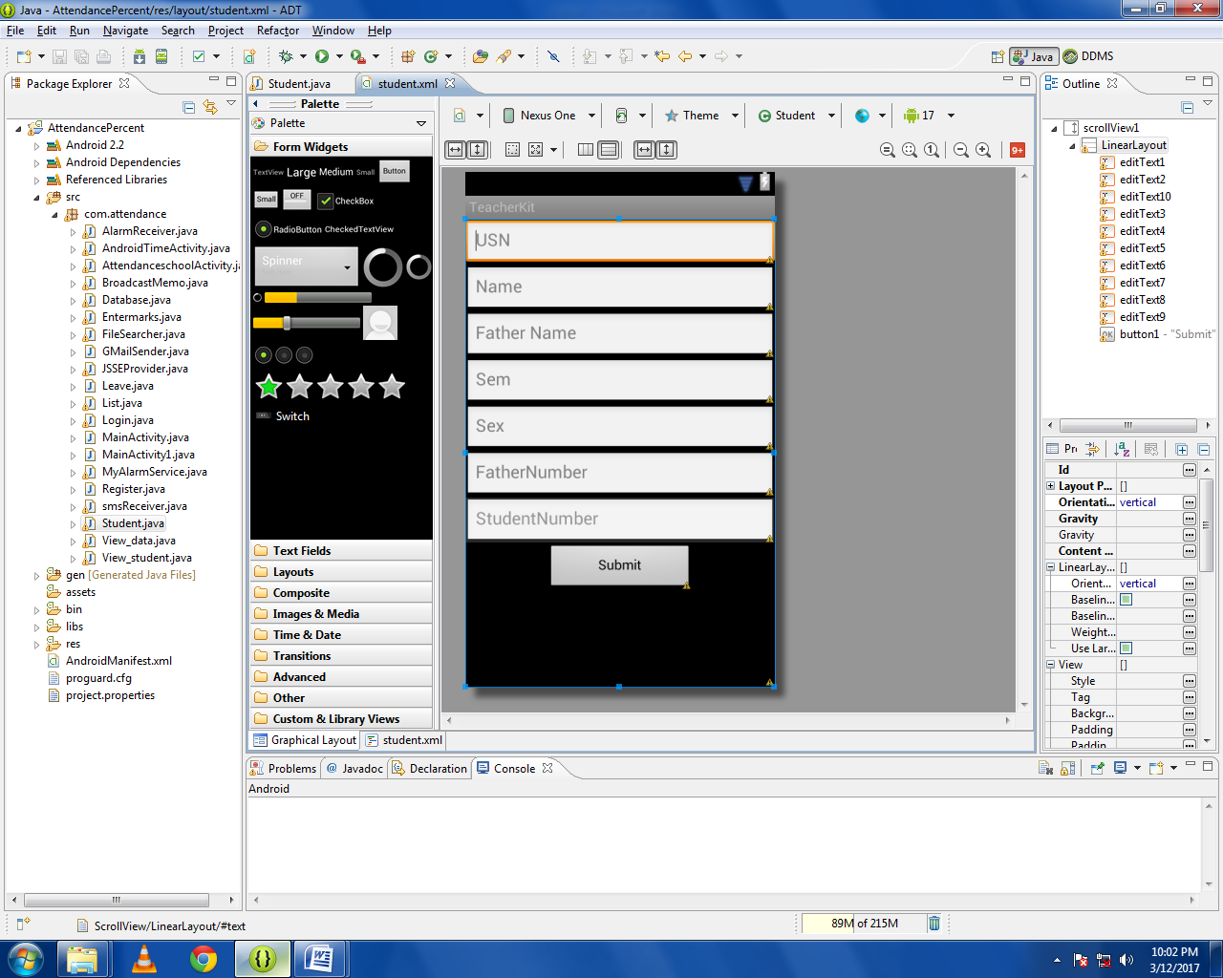
ATTENDANCE

MARKS
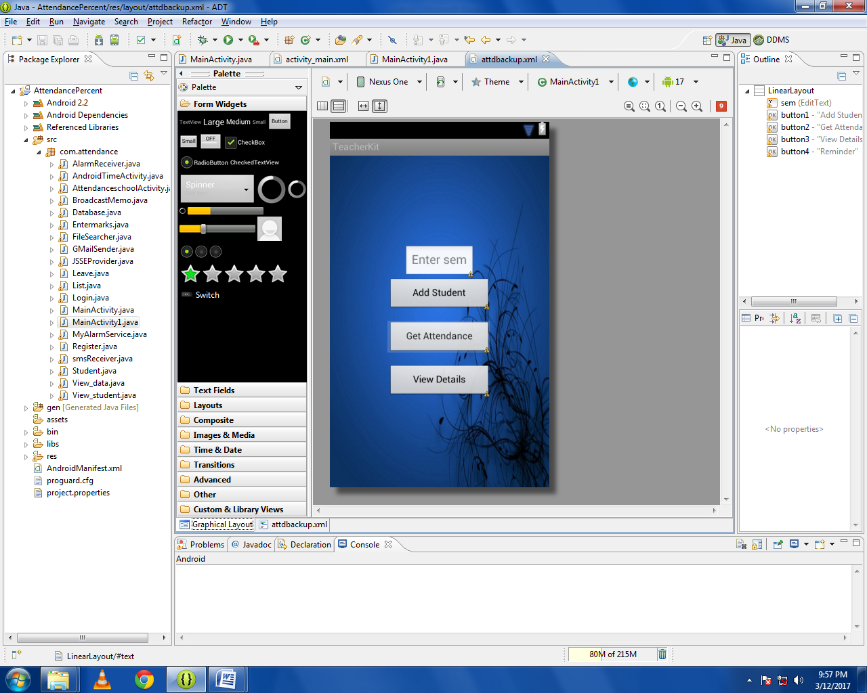

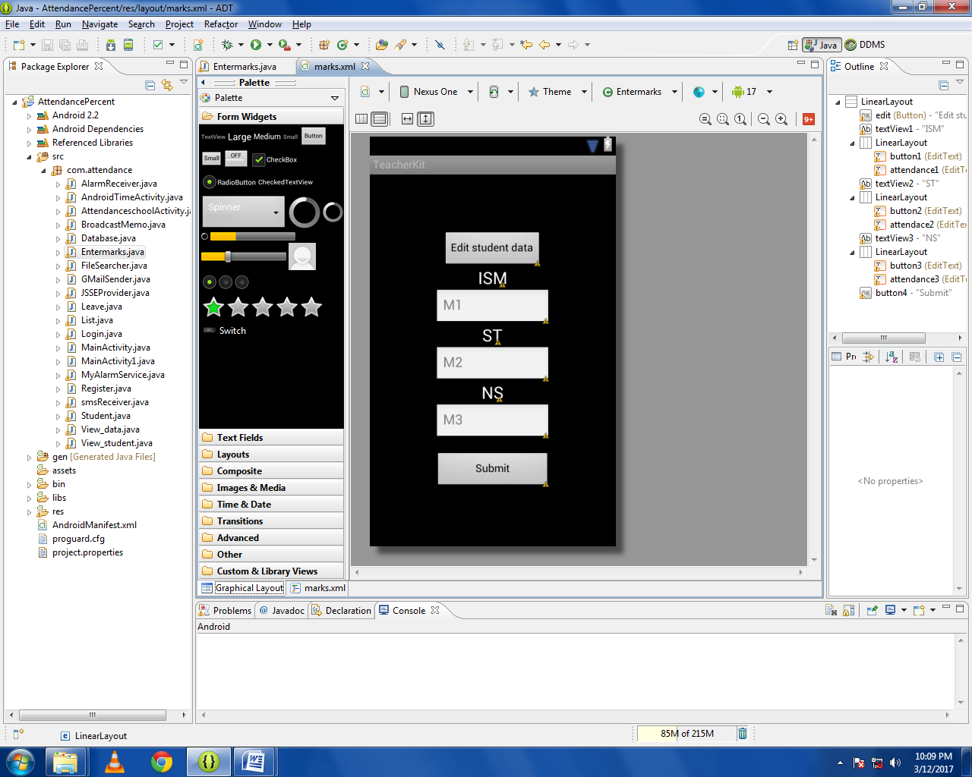

CONCLUSION
- In previous days instructor use the paper work to take attendance which to leads to wastage of time , hence using this system will not only save the time but also the effort of the instructor.
- The attendance in this system is secured and proxy will be avoided.
- This system provides the easy way for the students to access their particular notes of a specific subject.
- Timetable and memo sharing in easy way.

FUTURE APPLICATION OF PROJECT
- This system also notifies the pupil’s parents via SMS alerts of student performance also behaviour how they react and attendance of the student and also for lecturers.
- It can enhanced through GPS tracking that is, if a student donot attend the class they can br tracked with the location.
- Database can be created for lectures for applying leave.
- An application for Transfer Certificate is built.
These are the future enhancement of this application. It can be adopted easily in every colleges so the risk and wastage of time is saved.

BIBLIOGRAPHY

- https://thesai.org/.../Paper_10-A_Students_Attendance_System_Using_QR_Code.pdf
- www.ijltet.org/wp-content/uploads/2013/02/38.pdf
- ijiset.com/vol2/v2s7/IJISET_V2_I6_51.pdf

